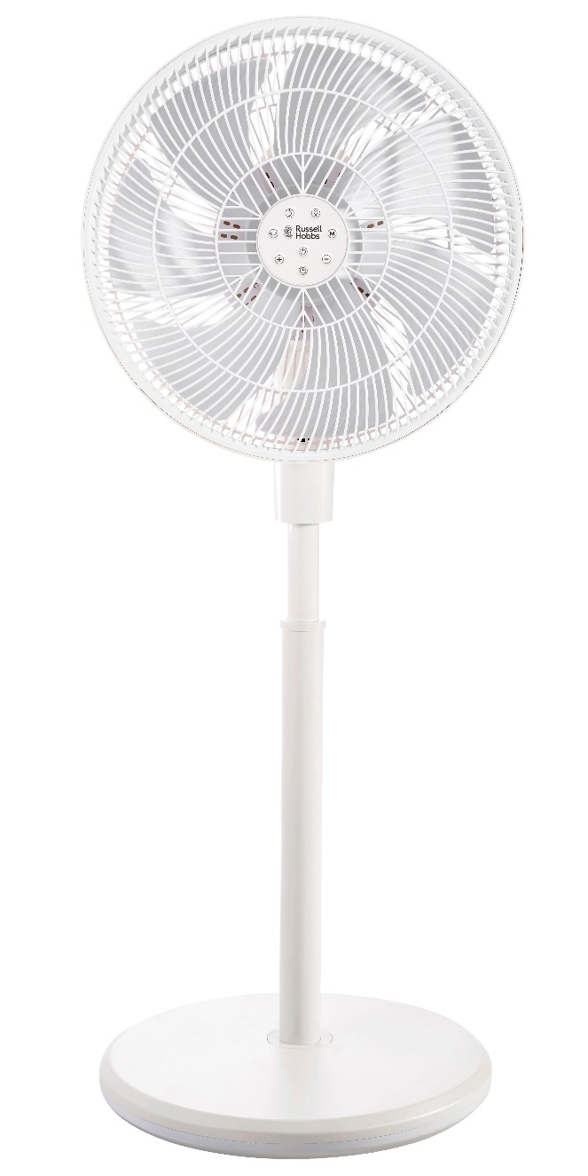

MODEL No. RHRCF35

Russell Hobbs Rechargeable Circulation Fan

Congratulations on purchasing your Russell Hobbs Rechargeable DC Circulation Fan. Each unit is manufactured to ensure safety and reliability. Before using the fan for the first time, please read the instruction manual carefully and keep it for future reference.

**FEATURES OF THE RUSSELL HOBBS RECHARGEABLE DC CIRCULATION FAN**

* 35cm DC Circulation Fan
* 2600mAh long lasting battery
* Run time
  + Fan only:
    - 4.5 hours (highest fan setting)
    - 24 hours (lowest fan setting)
  + Light and Fan:
    - 10 hours (on the lowest light setting, oscillation angle and fan speed)
    - 3.5 hours (on the highest light setting, oscillation angle and fan speed)
* 35W
* 12 Speed settings
* Room temperature display
* Auto left and right oscillation
* Auto up and down oscillation
* 4 Fan modes (normal/natural/sleep/ECO)
* 9 Hour auto shut off feature
* Ambient night lamp function
* Easy to use remote control
* Adjustable height
* Recharging Time: 3.5 hour
* 1 year standard warranty. Warranty will be extended for another year if you register your product online within 12 months of purchase (visit https://russellhobbswarranty.co.za/)

**IMPORTANT SAFEGUARDS**

When using any electrical appliance, basic safety precautions should always be followed including the following:

1. Please read the instructions carefully before using any appliance.

2. Always ensure that the voltage on the rating label corresponds to the mains voltage in your home.

3. Incorrect operation and improper use can damage the appliance and cause injury to   
the user or property.

4. The appliance is intended for household use only. Commercial use invalids the warranty and the supplier cannot be held responsible for injury or damage caused when using the appliance for any other purpose than that intended.

5. Avoid contact with all moving parts.

6. This appliance is not intended for use by persons (including children) with reduced physical, sensory or mental capabilities, or lack of experience and knowledge, unless they have been given supervision or instruction concerning use of the appliance by a person responsible for their safety

7. Close supervision is required when any appliance is used near or by children or invalids.

8. Check the power cord and plug regularly for any damage. If the cord or the plug is damaged, it must be replaced by the manufacturer or a qualified person in order to avoid an electrical hazard.

9. Do not use the appliance if it has been dropped or damaged in any way. In case of damage, take the unit in for examination and/or repair by an authorised service agent.

10. To reduce the risk of electric shock, do not immerse or expose the motor assembly, plug or the power cord to water or any other liquid.

11. Never immerse the unit in water or any other liquid for cleaning purposes.

12. Remove the plug from the socket by gripping the plug. Do not pull on the cord to disconnect the appliance from the mains. Always unplug the unit when not in use, before cleaning or when adding or removing parts.

13. The use of accessory attachments that are not recommended or supplied by the manufacturer may result in injuries, fire or electric shock.

14. A short charging cord is provided to reduce hazards resulting from becoming entangled in or tripping over a longer cord.

15. Do not let the cord hang over the edge of a table or counter. Ensure that the cord is not in a position where it can be pulled on inadvertently.

16. Do not allow the cord to touch hot surfaces and do not place on or near a hot gas or electric burner.

17. Use of an extension cord with this appliance is not recommended. However, if it is necessary to use an extension lead, ensure that the lead is suited to the power consumption of the appliance to avoid overheating of the extension cord, appliance or plug point. Do not place the extension cord in a position where it can be pulled on by children or animals or tripped over.

18. This appliance is not suitable for outdoor use. Do not use this appliance for anything other than its intended use.

19. Do not carry the appliance by the power cord.

20. Do not leave this appliance unattended during use. Always unplug the unit when not in use or before cleaning.

21. Always operate the appliance on a smooth, even, stable surface near a power socket.

22. The manufacturer does not accept responsibility for any damage or injury caused by improper or incorrect use, or for repairs carried out by unauthorised personnel.

23. Do not use the appliance near water or outdoors.

24. This appliance must not be operated by an external timer or remote-control system.

27. Turn the fan OFF and unplug the fan from the outlet when not in use, when moving the fan from one location to another and before cleaning.

28. Do not hang or mount fan on a wall or ceiling.

29. If the cable is damaged, return the fan, in order to avoid hazard.

|  |  |
| --- | --- |
| **techniCAL cHaractEristiCs** | |
| Model No.: | RHRCF35 |
| Rated Voltage: | 100V-240V ~ |
| Rated Frequency: | 50Hz |
| Power Input: | 35 W |
| Protection Class | II |
| Blade Size: | 350 mm |

**PARTS IDENTIFICATION AND ASSEMBLY**

**Parts Identification**

|  |  |  |  |
| --- | --- | --- | --- |
| **iNDEX** | **pART NAME** | **iNDEX** | **pART NAME** |
| 1. | Remote control | 10. | Blade cap |
| 2. | Remote control sensor | 11. | Fan blade |
| 3. | Ambient light | 12. | Nut to fasten grill |
| 4. | Carry Handle | 13. | Rear fan grill |
| 5. | Touch pad | 14. | Motor assembly set |
| 6. | Display panel | 15. | Tube assembly |
| 7. | Joint button | 16. | Base nut |
| 8. | Height adjust button | 17. | Base (with built-in battery) |
| 9. | Front fan grill | 18. | Power cord |

**Fan assembly**

|  |  |
| --- | --- |
|  | |
| 1. Match the tube assembly [15] to the slot of the base [17], and fasten it in a clockwise direction with the base nut [16]. | 1. Insert the motor assembly set [14] into  the corresponding location of the tube  assembly [15].   *NOTE:* the motor assembly will be reset to right position if the battery has sufficient charge. |
|  | |
| 1. Insert the rear fan grill [13] into the slot of the motor set [14], fasten it with rotating the grill fasten nut [12] clockwise.   Then fix the fan blade [11] to the blade  cap [10] by turning counterclockwise. | 1. Match the slots of front fan grill [9] and  rear fan grill [13], then turn clockwise to  the locking point. |
|  | |
| 1. Fasten the fan grills with screws at  the bottom. | 1. Insert the power cord [18] at the back side of the base [17]. |

**OPERATING INSTRUCTIONS**

* Place the unit on a firm level surface.
* Insert 1x CR2032 battery (not included) into the remote.
* Avoid overloading the circuit by not plugging other high wattage products into the same power socket.
* Please ensure the unit is OFF before plugging into the power socket.

**Display screen & Control panel**

**OPERATION**

When the unit is plugged into the socket and switched on (when charging or powered by the chord), the fan will oscillate and reset automatically to its central position.

One the unit has been switched on, the display panel brightness will decrease to 50%   
after 15 seconds and enter to hibernation mode after 30 seconds once a function selection has been made.

|  |  |
| --- | --- |
| ON/OFF: | Press this button to turn on the fan. The fan will automatically start at the first speed setting.  Press it again to turn off the fan. The fan will oscillate and reset automatically to the central position. |
| SPEED: | Press this button to switch the fan from 1 - 12 speed settings in **Normal** mode.  This can also be achieved by pressing “+” or “-” buttons on the remote control. |
| V-OSC: | Press this button to start the **vertical oscillation** function at its smallest angle  (max 60º). The icon on the display panel will be BLUE.  Press this button again to switch the **vertical oscillation** function to its largest angle (max 100º). The icon on the display panel will be RED.  Press this button at a third time to stop the vertical oscillation. |
| H-OSC: | Press this button to start the **horizontal oscillation** function at its smallest angle (max 60º). ). The icon on the display panel will be BLUE.  Press this button again to switch the **horizontal oscillation** function to its largest angle (max 120º). The icon on the display panel will be RED.  Press this button at a third time to stop the horizontal oscillation. |
| AMBIENT LIGHT: | Press this button to turn the night light function on.  The default brightness is 50%.  Pressing this button twice will increase the brightness to 100.  Press this button at a third time to turn off the light.  Hold the button for 3 seconds - the fan head will rotate to 90º to allow for use as an independent ambient light. Press the button again to turn off the night light function - the fan head will reset to its central position.  Please note: the fan will not work in this independent ambient night light mode. |
| TIME: | Press this button repeatedly to increase the timer setting in  1 hour increments (up to a maximum of 9 hours) as indicated on the LED display. After 5 seconds, the timer will begin. Once the timer has run out, the unit will automatically switch off. |
| MODE: | Press to select **Normal** mode, **Natural Breeze** mode, **Sleep** mode or **ECO** mode. (As indicated on the LED Display).  NORMAL mode: Fan operates at the speed selected with the ‘SPEED’ button.  NATURAL mode: Fan speed varies automatically to simulate a  natural breeze.  SLEEP mode: Fan speed varies automatically for use during sleep.  ECO mode: Fan speed varies as below table.   |  |  |  |  |  |  | | --- | --- | --- | --- | --- | --- | | TEMP. (OC) | ≤22 | 23~25 | 26~28 | 29~31 | ≥32 | | SPEED | 1 | 3 | 5 | 9 | 12 | |



**Charging Mode**

The unit is functions with a configured power cord or built-in battery (Lithium-ion Rechargeable Cell 3.7V, 9.25Wh, 2500mAh)

1. Charging status:

When the unit functions with its configured power cord, it is charged automatically.   
A green indicator light flashes until fully charged. The maximum fan velocity can be set to SPEED 12.

1. Discharging status:

When the unit is functioning with its built-in battery (cordless operation), it is in its discharging phase. The maximum fan velocity can only be set to SPEED 9. The other operating features remain functioning.

1. No indicator light displayed when battery capacity is more than 30%.
2. Red indicator light flashes when battery capacity is equal to or less than 30%.
3. Red indicator light stops flashing and unit shuts down automatically if battery capacity is equal to or less than 10%. Plug the unit in to recharge its battery.

**Height Adjusting**

Hold the tube assembly and press the joint button at the back end to adjust the height of the unit.

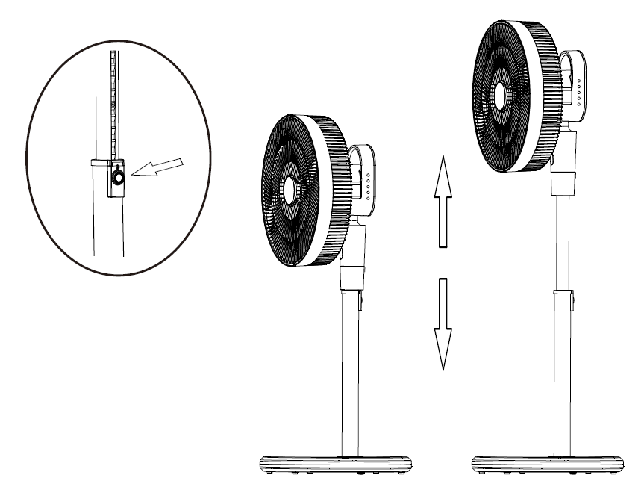

**CLEANING AND STORAGE**

Before cleaning, turn the unit off and unplug from the power supply.

To clean the unit use a soft cloth to wipe off any dust.

Keep the unit in a cool and dry place when not to be used for a long time.

Dismantle the fan as below steps to clean the fan blade.

|  |  |  |
| --- | --- | --- |
|  | | |
| 1. Release the screws at the bottom of the fan grill. | 2. Hold the ribs of the front fan grill, and rotate it counter-clockwise to unlock, and take out the front fan grill. |
|  | | |
| 3. Release the fan blade by rotating the  fan blade nut clockwise, and take out the fan blade. | 4.Loosen the grill nut by rotating it  counter-clockwise and remove the  rear fan grill. |

NOTE: After cleaning the unit, re-assembly the fan or arrange a proper storage.

**SERVICING THE APPLIANCE**

There are no user serviceable parts in this appliance. If the unit is not operating correctly, please check the following:

* You have followed the instructions correctly.
* That the unit has been wired correctly and that the wall socket is switched on.
* That the mains power supply is ON.
* That the plug is firmly in the mains socket.

If the appliance still does not work after checking the above:

Consult the retailer for possible repairs or replacement. If the retailer fails to resolve the problem and you need to return the appliance, make sure that:

* The unit is packed carefully back into its original packaging.
* Proof of purchase is attached.
* A reason is provided for why it is being returned.

If the supply cord is damaged, it must be replaced by the manufacturer or an authorised service agent, to avoid any hazard. If service becomes necessary within the warranty period, the appliance should be returned to an approved Home of Living Brands (Pty) Ltd service centre. Servicing outside the warranty period is still available, but will, however, be chargeable.

**CHANGING THE PLUG**

Should the need arise to change the fitted plug, follow the instructions below. This unit is designed to operate on the stated current only. Connecting to other power sources may damage the appliance.

**PLEASE AFFIX YOUR PROOF OF PURCHASE/RECEIPT HERE**

**IN THE EVENT OF A CLAIM UNDER WARRANTY THIS RECEIPT MUST BE PRODUCED.**

***1 YEAR STANDARD WARRANTY***

*Warranty will be extended for another year if you register your product online within 12 months of purchase (visit* [*https://russellhobbswarranty.co.za/*](https://russellhobbswarranty.co.za/)

***WARRANTY AND EXTENDED WARRANTY***

1. Home of Living Brands (Pty) Limited ("Home of Living Brands") warrants to the original purchaser of this product ("the customer") that this product will be free of defects in quality and workmanship which under normal personal, family or household use and purpose may manifest within a period of 1 (one) year from the date of purchase ("warranty period").
2. Home of Living Brands shall extend the warranty period for a further period of 1(one) year (“extended warranty period*”), on condition that the purchaser registers the product on the website, within 12 months from the date of purchase of the product. The website address for registration is as follows: <https://russellhobbswarranty.co.za/>.
3. Where the customer has purchased a product and it breaks, is defective or does not work properly for the intended purpose, the customer must notify the supplier from whom the customer bought the product ("the supplier") thereof within the warranty period or if applicable, the extended warranty period. Any claim in terms of this warranty must be supported by a proof of purchase. If proof of purchase is not available, then repair, and/or service charges may be payable by the customer to the supplier.
4. The faulty product must be taken to the supplier's service centre to exercise the warranty.
5. The supplier will refund, repair or exchange the product in terms of this warranty subject to legislative requirements. This warranty shall be valid only where (a) the customer is not the cause of the product breaking, and (b) the product has been used for the intended purpose stipulated in the product manual. The warranty does not include and will not be construed to cover products damaged as a result of disaster, misuse, tamper, abuse or any unauthorised modification or repair of the product.
6. This warranty will extend only to the product provided at the date of the purchase and not to any expendables attached or installed by the customer. In this regard any accessories supplied with the product by the supplier, may be excluded in this warranty or extended warranty (see Exclusions to Warranty and Extended Warranty document).
7. If the customer requests that the supplier repairs the product and the product breaks or fails to work properly within 3 (three) months of the repair and not as a result of misuse, tampering or modification by or on behalf of the customer, then the supplier may replace the product or pay a refund to the customer, subject to the supplier’s discretion.
8. The customer may be responsible for certain costs where products returned are not in the original packaging, or if the packaging is damaged. This will be deducted from any refund paid to the customer.

**HOME OF LIVING BRANDS (PTY) LTD (JOHANNESBURG)**

NATIONAL CONTACT TEL NO. (087) 245 - 0029

www.homeoflivingbrands.com

www.russellhobbs.co.za

[www.facebook.com/RussellHobbsSA](http://www.facebook.com/RussellHobbsSA)

*EXCLUSIONS TO WARRANTY AND EXTENDED WARRANTY*

1. Any accessories supplied with the product, including but not limited to, bowls, jugs, mills or carafes made either of glass or plastic and supplied with this appliance (hereinafter referred to as “the accessory or accessories”), is warranted to be free from material and workmanship defects for the duration of the appliance warranty.
2. The accessories should give trouble free service when used in accordance with the directions described in the instruction manual. However, the accessories will be damaged if subjected to impact, and this damage is not covered by the warranty. Such impact damage can occur either from the outside (if for example it is dropped or knocked against a hard surface), or from within (if for example foreign objects are placed within the accessories and the power is switched on).
3. Should you need to replace an accessory during the warranty period; a claim for a free replacement will only be considered if the item (including all shards and broken parts) is returned to the nearest HOLB service centre for examination.
4. The remains of the accessory will be carefully examined by the relevant professionals and if it is determined (at the sole discretion of HOLB) that the damage was caused by impact, then the claim will be refused and will not be covered by the warranty or any extended warranty.
5. Any replacement part provided in terms of clause 4 above will become a chargeable item payable by the customer.

# Explanation of Symbols on the Product Rating Label



Read the Instruction Manual



WEEE (Waste from Electrical and Electronic Equipment)

Should be re-cycled and NOT to be disposed of in the land fill

For Indoor use ONLY

DO NOT Immerse in any liquid

DO NOT Cover

Class II appliance

Double insulated, does not require an earth connection